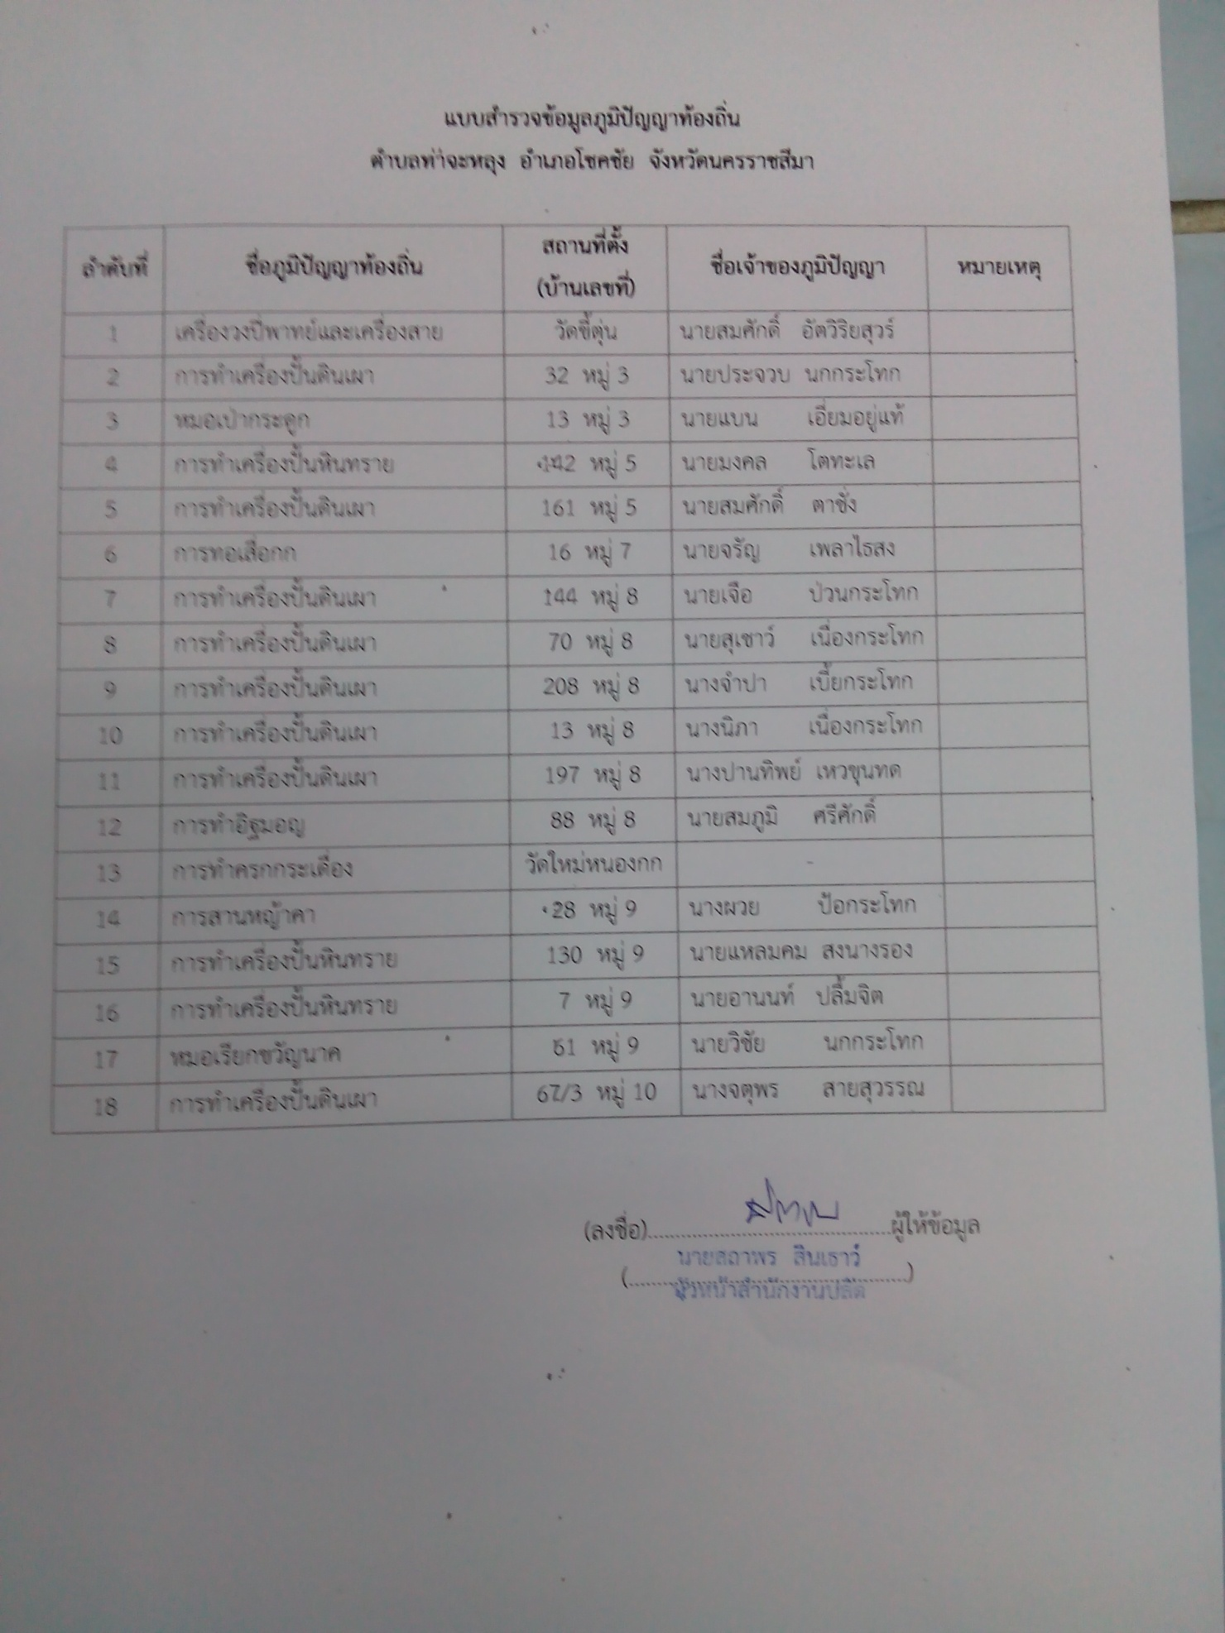

[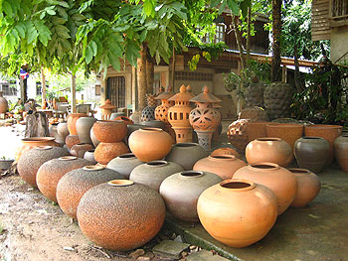](http://www.google.co.th/url?sa=i&rct=j&q=&esrc=s&source=images&cd=&cad=rja&uact=8&ved=0ahUKEwjFw7f8o4PVAhXMq48KHeA1ArgQjRwIBw&url=http%3A%2F%2Fwww.manager.co.th%2FTravel%2FViewNews.aspx%3FNewsID%3D9490000106428&psig=AFQjCNFMEaZ1inaRqFCTbcFtNAAG5kILOA&ust=1499932987426343)

[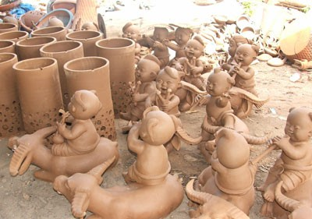](http://www.google.co.th/url?sa=i&rct=j&q=&esrc=s&source=images&cd=&cad=rja&uact=8&ved=0ahUKEwiz3umhpIPVAhUXSY8KHUERALUQjRwIBw&url=http%3A%2F%2Fwww.teawtourthai.com%2Fnakhonratchasima%2F%3Fid%3D1276&psig=AFQjCNFMEaZ1inaRqFCTbcFtNAAG5kILOA&ust=1499932987426343)

[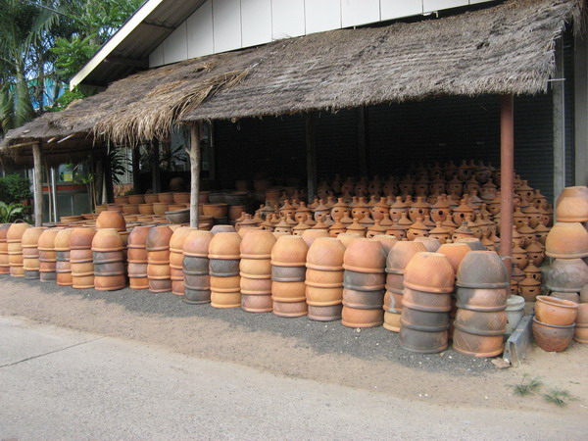](https://www.google.co.th/url?sa=i&rct=j&q=&esrc=s&source=images&cd=&cad=rja&uact=8&ved=0ahUKEwjuoe-8pIPVAhUKRo8KHfClC7IQjRwIBw&url=https%3A%2F%2Fw.pantip.com%2Fcafe%2Fblueplanet%2Ftopic%2FE12550374%2FE12550374.html&psig=AFQjCNFMEaZ1inaRqFCTbcFtNAAG5kILOA&ust=1499932987426343)

[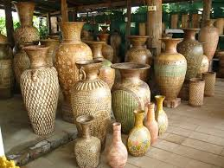](http://www.google.co.th/url?sa=i&rct=j&q=&esrc=s&source=images&cd=&cad=rja&uact=8&ved=0ahUKEwiD29rQpIPVAhUFpJQKHRhTCEAQjRwIBw&url=http%3A%2F%2Ftopicstock.pantip.com%2Fhome%2Ftopicstock%2F2011%2F01%2FR10160492%2FR10160492.html&psig=AFQjCNFMEaZ1inaRqFCTbcFtNAAG5kILOA&ust=1499932987426343)